A000-Asia-China-Guang-Muntjak-Bronze-c 1100 BCE

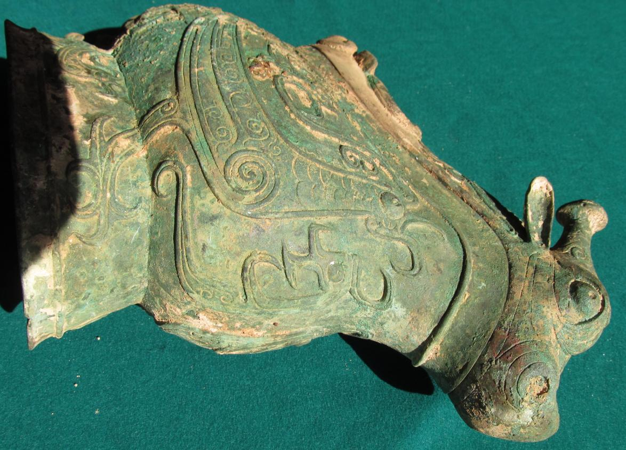

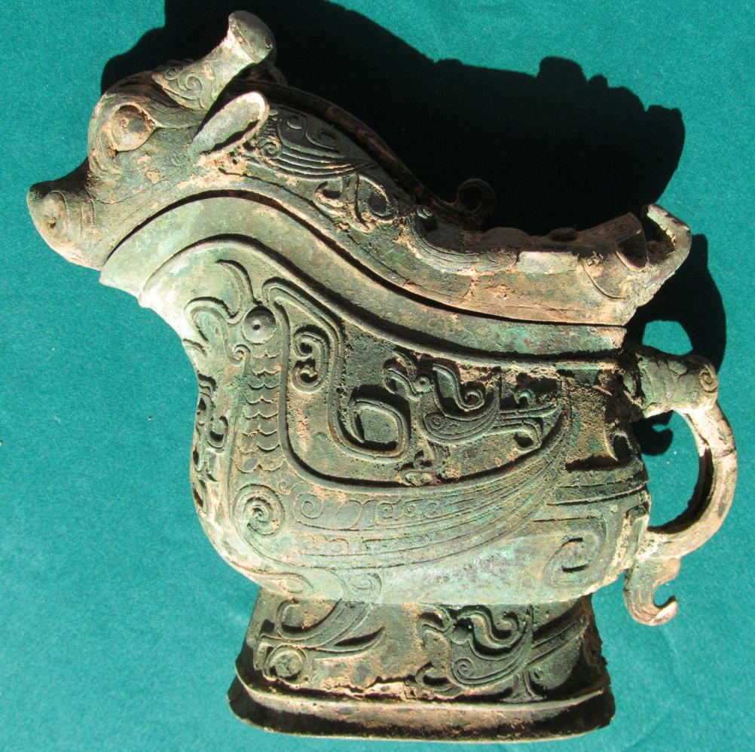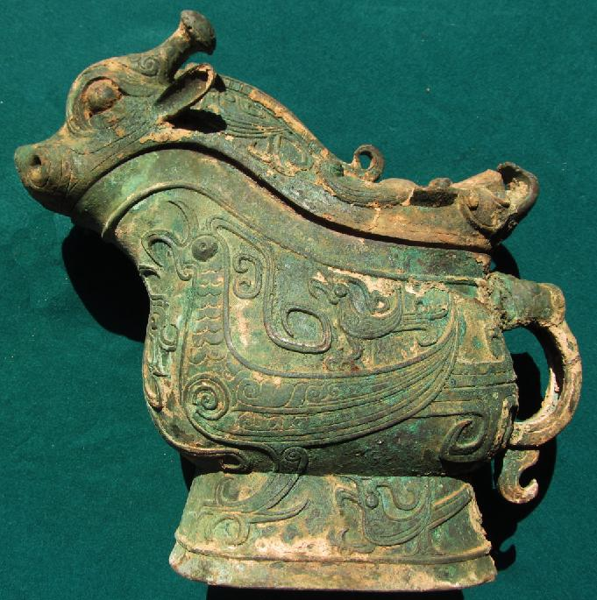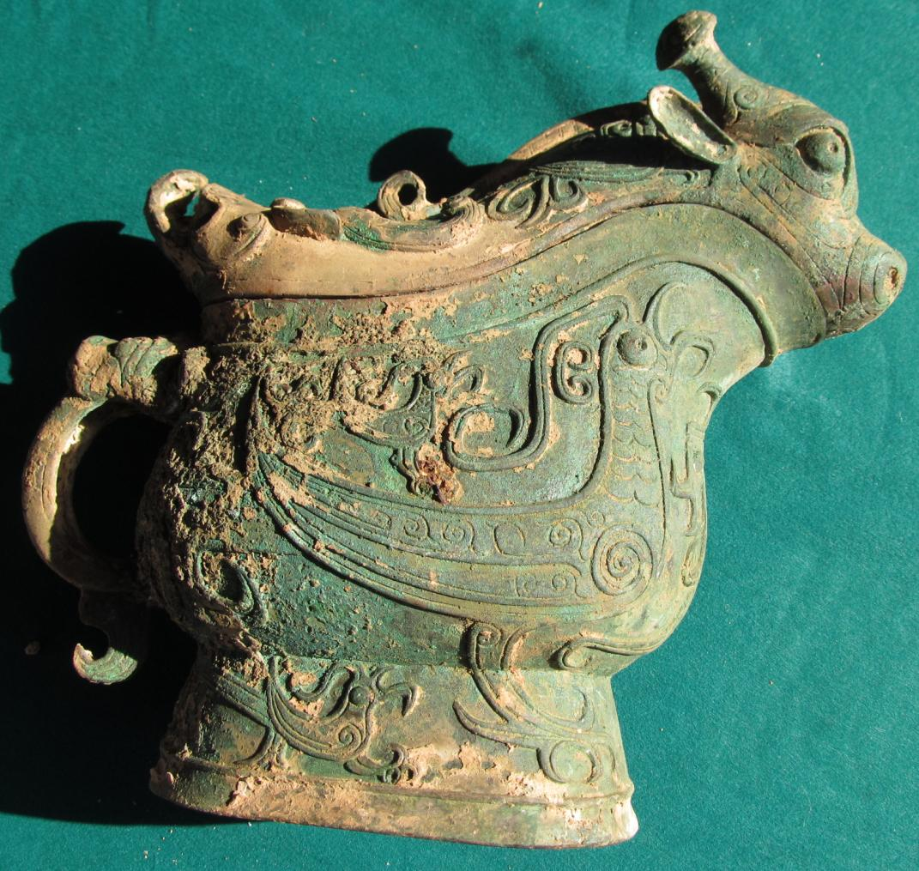

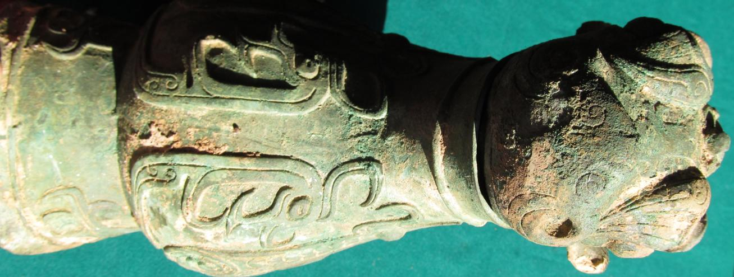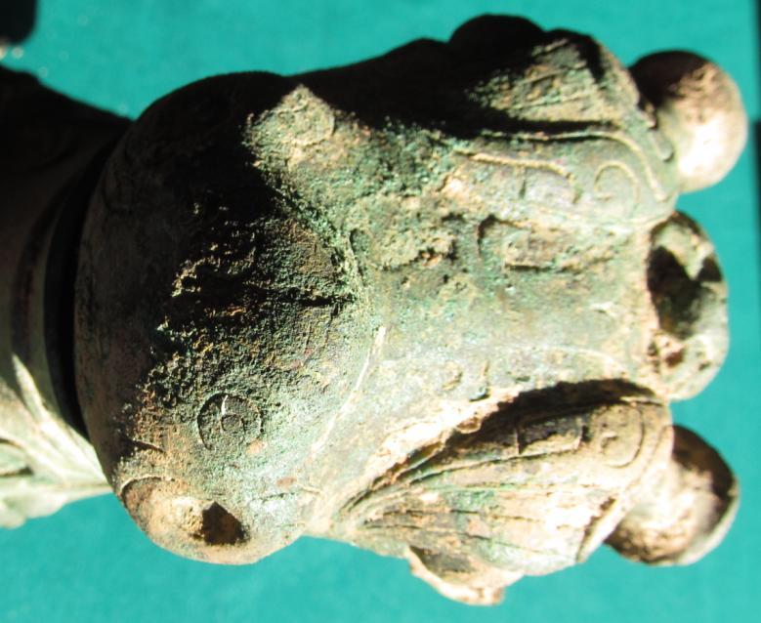

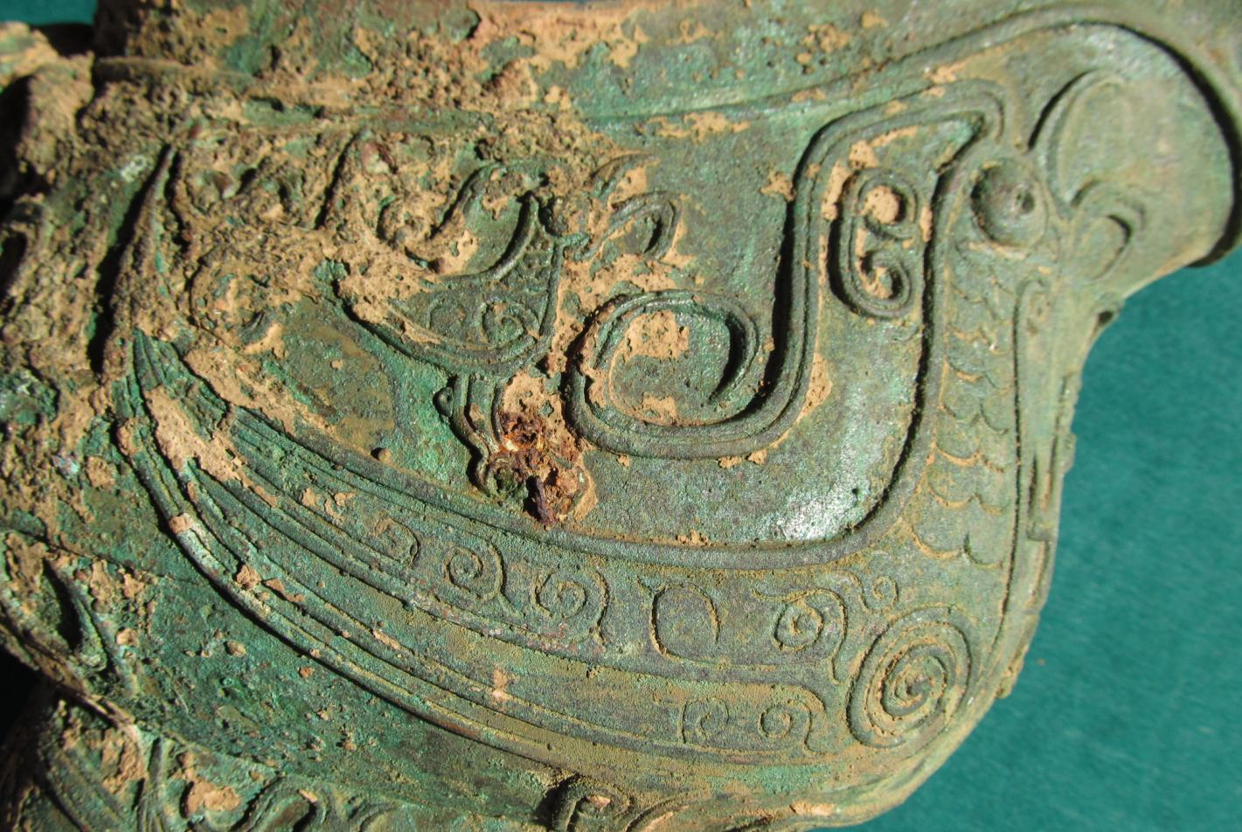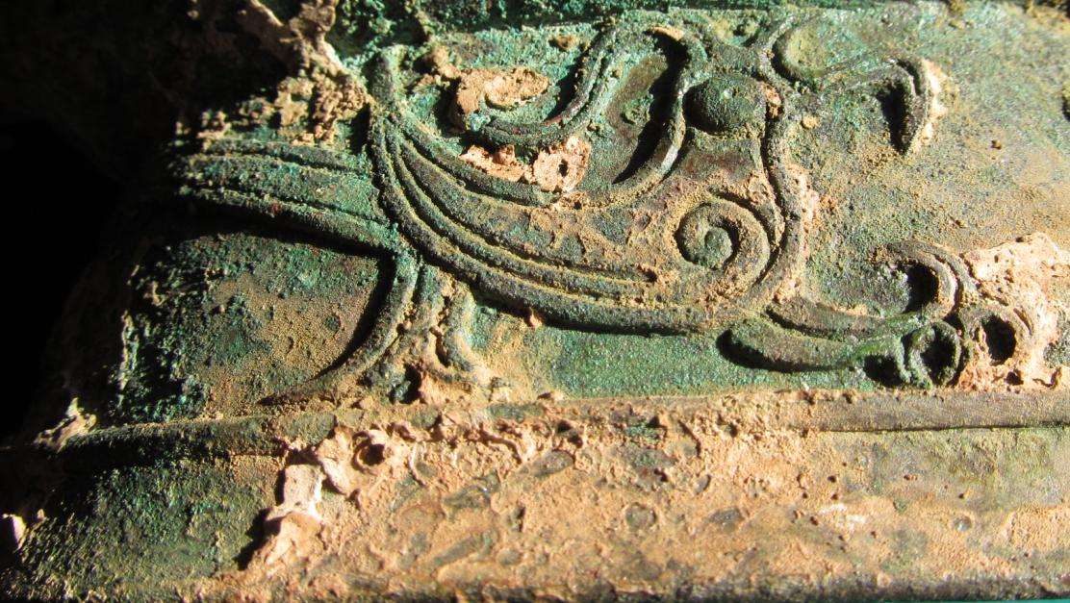

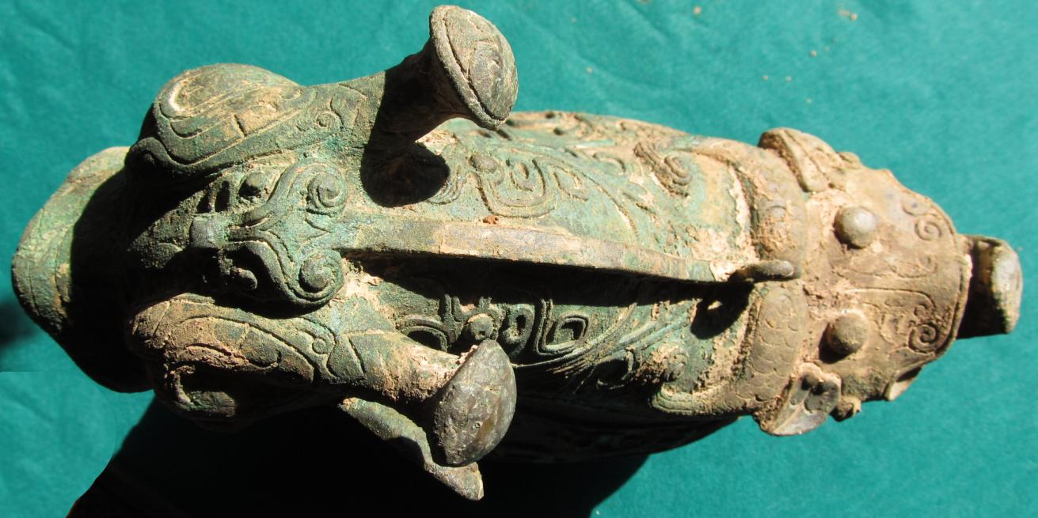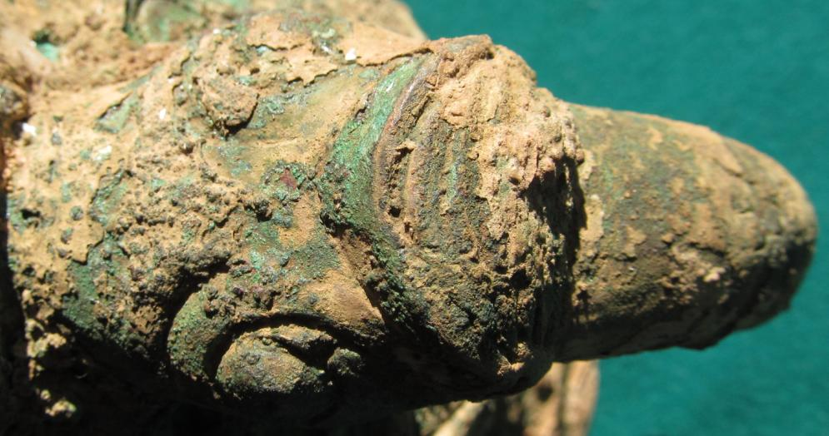

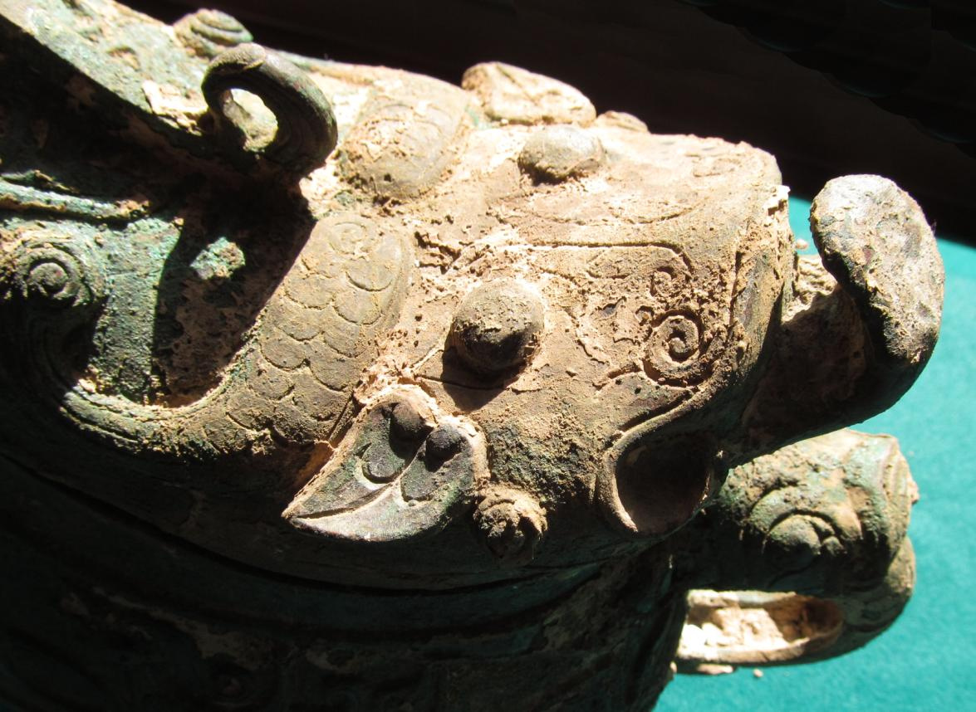

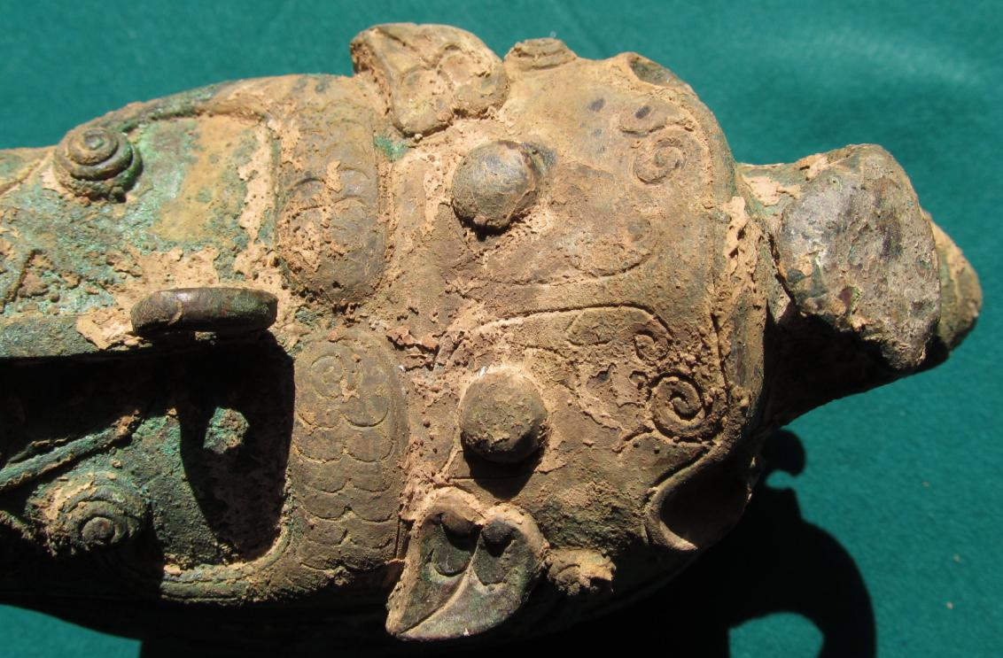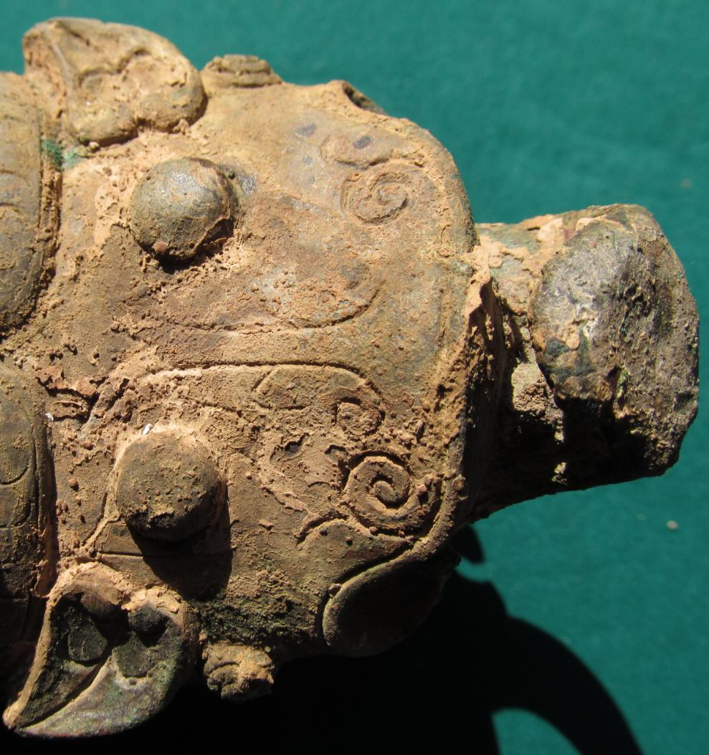

China-Guang-Muntjak-Bronze-c 1100 BCE

**Case No.: 5**

**Accession No.**

**Formal Label:** China-Guang-Muntjak-Bronze-c 1100 BCE

**Display Description: After https://en.wikipedia.org/wiki/Ritual_wine_server_(guang),_Indianapolis**

This ritual wine server or *guang* is a bronze, piece-mold cast vessel complete with removable lid. Adorning the surface of the vessel are three primary decorative animal motifs, including fifteen imaginary creatures cast in relief along the sides. (Indianapolis Museum of Art 2012; Mino and Robinson 1983), The first animal depicted is apparent in the overall shape and design of the removable lid. Here a battle-horned beast dominates the wide spout, with its large head merging seamlessly with reverse-S shaped bodies descending to the base of the vessel. Under the spout, the beast’s forepaws appear posed in a position indicating the animal is rearing up on its hind legs. The second animal motif is that of a taotie, a mask of the animal master of the Paleolithic ancestors of the Shang Chinesewho now sits at the end of the lid, depicted with zoomorphic horns and a sharp, upward curved base. The final animal motif consists of a scaled, serpent-like dragon along the rear register of the vessel. This dragon is curved to look back upon its own tail and the front of the guang. In addition to these three creatures, small birds and dragons have been cast in low relief along the vessel’s upper register and the handle is designed to resemble the scaled body of an unidentified creature with an animal face molded into the upper curve.

Cast into the underside of the lid is a Chinese character, likely a signature from the vessel’s original owner depicting the owner’s tribe sign. This particular clan sign has also been noted within several other bronze artifacts dated from this period. For example, a "lei" vessel in the Shanghai Museum collection (H. 46.5 cm), recorded in Zhongguo qingtongqi quanji 3.83 (see also Jinchu yinzhou jinwen jilu erbian, Vol.3, p.197). In the Museum für Ostasiatische Kunst Köln is a "fangyi" vessel (H. 26.5 cm) that also carries the same emblem (Bagley 1987:137). A third example is the Metropolitan Museum of Art "zun" vessel (H. 39.7 cm), accession number 43.25.1.

Cast during the Shang dynasty (c 1600–1050 BCE), this wine vessel is representative of the highly evolved piece-mold technologies developed within China’s Bronze Age. (Metropolitan Museum of Art 2000). Due to the large number of surviving bronze vessels from this era, scholars have deduced that this age in China’s history must have been a highly developed state with strong control over resources such as copper, tin, and lead, needed to create the alloy bronze. Additionally, the Chinese technique of using piece-mold casting was considered extremely sophisticated compared to the lost-wax method used by other world cultures during their own Bronze Ages. During piece-mold casting, the object to be created is first designed as a model, and then enclosed in a clay mold that can be cut into pieces to remove it from the model. These clay pieces are then decorated or stamped with intricate designs before being fired back together, creating a mold for the bronze casting. For vessels such as this one, the central cavity of the container would have been created by placing a core inside the mold before casting with molten bronze. By casting the objects into molds already decorated with designs, craftsmen were able to use this technique to attain a higher level of definition than in any previously utilized casting methods (The Metropolitan Museum of Art 2000,) Furthermore, unlike many other early bronze wine vessels, guang have no history of prior ceramic prototypes, marking them as unique casts specifically from the Shang and Zhou dynasties (The Brooklyn Museum 2011).

**LC Classification:**

**Date or Time Horizon: c 1100 BCE**

**Geographical Area:**

**Map:**

**GPS coordinates:**

**Cultural Affiliation: Shang**

**Media:**

**Dimensions:**

**Weight:**

**Condition:**

**Provenance:**

**Discussion:**

**References:**

[Indianapolis Museum of Art](https://en.wikipedia.org/wiki/Indianapolis_Museum_of_Art). 2012. Ritual wine server (guang), retrieved 18 July 2018.

[The Brooklyn Museum](https://en.wikipedia.org/wiki/Brooklyn_Museum) (2011), [Collections: Asian Art: Ritual Wine Vessel (Guang)](http://www.brooklynmuseum.org/opencollection/objects/99294/Ritual_Wine_Vessel_Guang), retrieved 18 July 2018.

[Metropolitan Museum of Art, Department of Asian Art](https://en.wikipedia.org/wiki/Metropolitan_Museum_of_Art). 2000. [Shang and Zhou Dynasties: The Bronze Age of China](http://www.metmuseum.org/toah/hd/shzh/hd_shzh.htm), retrieved 18 July 2018.

Mino, Yutaka; Robinson, James 1983. Beauty and Tranquility: The Eil Lilly Collection of Chinese Art. Indianapolis: [Indianapolis Museum of Art](https://en.wikipedia.org/wiki/Indianapolis_Museum_of_Art). pp. 100–101.